SQL Server 2008 Setup Steps

Date Issued: 19/12/2009

Table of Contents
1 SQL Server Setup Steps 3
1.1 Engine Configuration 3
1.2 Enable Named Pipes 4
1.3 SQL Cache Invalidation 4
1.4 Recreate Logins 5

SQL Server Setup Steps

Engine Configuration

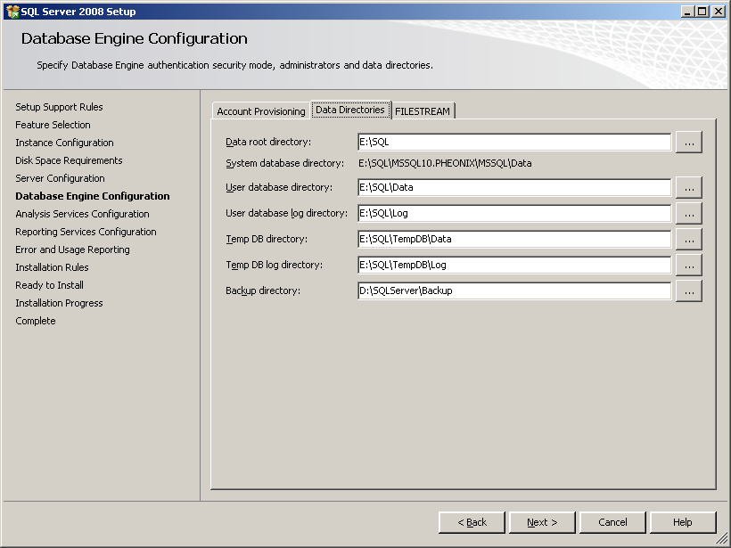
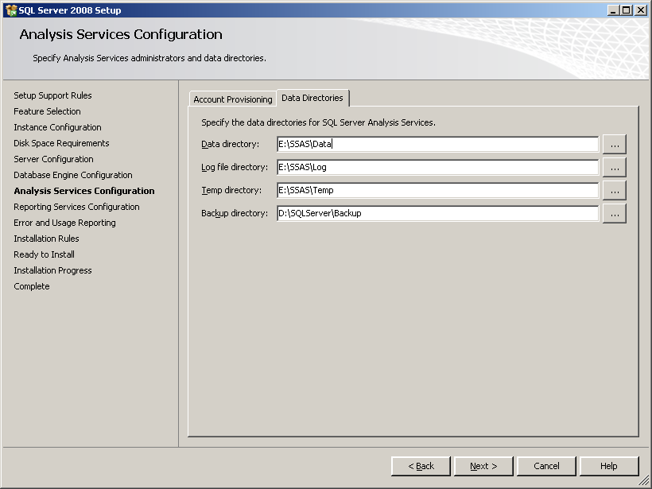

Enable Named Pipes
Named Pipes need to be enabled first

- Start > All Programs > Microsoft SQL Server 2008 > Configuration Tools > SQL Server Configuration Manager
- Enable Named Pipes under SQL Server Network Configuration > Protocols for PHEONIX
- In same tool, restart all SQL Server Services under SQL Server Services

SQL Cache Invalidation
Reference: http://techiemate.blogspot.com/2009/04/aspnet-20s-new-sql-server-based-cache.html

- Open a command prompt by selecting Start > Run > Programs > Microsoft Visual Studio 2008 > Visual Studio Tools > Visual Studio 2008 Command Prompt
- Execute the following commands from the command line to enable SQL Server to support SQL Cache Invalidation:

Database Level
aspnet_regsql -S PHEONIX\PHEONIX -U sa -P bond007 -d eStore -ed

Table Level
aspnet_regsql -S PHEONIX\PHEONIX -U sa -P bond007 -t Users -d eStore -et
aspnet_regsql -S PHEONIX\PHEONIX -U sa -P bond007 -t Alerts -d eStore -et
aspnet_regsql -S PHEONIX\PHEONIX -U sa -P bond007 -t AuditCategoryType -d eStore -et
aspnet_regsql -S PHEONIX\PHEONIX -U sa -P bond007 -t AuditLog -d eStore -et
aspnet_regsql -S PHEONIX\PHEONIX -U sa -P bond007 -t AuditEventType -d eStore –et
aspnet_regsql -S PHEONIX\PHEONIX -U sa -P bond007 -t BadWord -d eStore –et
aspnet_regsql -S PHEONIX\PHEONIX -U sa -P bond007 -t Brand -d eStore –et
aspnet_regsql -S PHEONIX\PHEONIX -U sa -P bond007 -t CustomerAddress -d eStore –et
aspnet_regsql -S PHEONIX\PHEONIX -U sa -P bond007 -t Links -d eStore –et
aspnet_regsql -S PHEONIX\PHEONIX -U sa -P bond007 -t Metrics -d eStore –et
aspnet_regsql -S PHEONIX\PHEONIX -U sa -P bond007 -t SavedSearch -d eStore –et
aspnet_regsql -S PHEONIX\PHEONIX -U sa -P bond007 -t SocialNetworking -d eStore –et
aspnet_regsql -S PHEONIX\PHEONIX -U sa -P bond007 -t Category -d eStore -et
aspnet_regsql -S PHEONIX\PHEONIX -U sa -P bond007 -t Department -d eStore -et
aspnet_regsql -S PHEONIX\PHEONIX -U sa -P bond007 -t Currency -d eStore -et
aspnet_regsql -S PHEONIX\PHEONIX -U sa -P bond007 -t CCExpiryYear -d eStore -et
aspnet_regsql -S PHEONIX\PHEONIX -U sa -P bond007 -t CCExpiryMonth -d eStore -et
aspnet_regsql -S PHEONIX\PHEONIX -U sa -P bond007 -t Email -d eStore -et
aspnet_regsql -S PHEONIX\PHEONIX -U sa -P bond007 -t Order -d eStore -et
aspnet_regsql -S PHEONIX\PHEONIX -U sa -P bond007 -t OrderDetail -d eStore -et
aspnet_regsql -S PHEONIX\PHEONIX -U sa -P bond007 -t ShipCost -d eStore -et
aspnet_regsql -S PHEONIX\PHEONIX -U sa -P bond007 -t ShipToCountry -d eStore -et
aspnet_regsql -S PHEONIX\PHEONIX -U sa -P bond007 -t ShipToMode -d eStore -et
aspnet_regsql -S PHEONIX\PHEONIX -U sa -P bond007 -t Supplier -d eStore -et
aspnet_regsql -S PHEONIX\PHEONIX -U sa -P bond007 -t Zone -d eStore -et
aspnet_regsql -S PHEONIX\PHEONIX -U sa -P bond007 -t Product -d eStore -et
aspnet_regsql -S PHEONIX\PHEONIX -U sa -P bond007 -t ProductColor -d eStore -et
aspnet_regsql -S PHEONIX\PHEONIX -U sa -P bond007 -t ProductSize -d eStore -et
aspnet_regsql -S PHEONIX\PHEONIX -U sa -P bond007 -t ProductImage -d eStore –et

- Add the following to the Web.config file immediately before <system.web>:
<connectionStrings>
<add name="eStoreConnectionString" connectionString="server=PHEONIX\PHEONIX;database=eStore;UID=eStoreUser;PWD=p@55word" />
</connectionStrings>
- Add the following to the Web.config file immediately after <system.web>:
<caching>
<sqlCacheDependency enabled="true" pollTime="60000">
<databases>
<add name="eStore" connectionStringName="eStoreConnectionString" pollTime="60000"/>
</databases>
</sqlCacheDependency>
</caching>

Recreate Logins
Restoring the database will leave the users orphaned from the logins. To recreate this link perform the following steps:

- Open SQL Server Management Studio and login
- Navigate to Database > eStore > Security > Users and delete user ‘eStoreUser’
- Navigate to Database > Security > Logins
- Double-Click on eStoreUser
- Go to Status Page
- Enable Login
- Go to User Mapping page
- Check the Map checkbox next to eStore
- Scroll to the bottom of the ‘Database role Membership’ pane
- Check the check box next to eStoreStoreRole

- Navigate to Database > eStore > Security > Users and delete user ‘eStoreAdminUser’
- Navigate to Database > Security > Logins
- Double-Click on eStoreAdminUser
- Go to Status Page
- Enable Login
- Go to User Mapping page
- Check the Map checkbox next to eStore
- Scroll to the bottom of the ‘Database role Membership’ pane
- Check the check box next to eStoreAdminRole

Note: Ensure the passwords for both logins match what is specified in the eStore solution.

AspNetServicesUser
- Delete user from AspNetServicesDB
- Delete Login AspNetServicesUser
- Create Login AspNetServicesUser
- Tick the following roles in User Mapping Tab:
  - aspnet_Membership_FullAccess
  - aspnet_Personalisation_FullAccess
  - aspnet_Profile_FullAccess
  - aspnet_Roles_FullAccess
  - db_owner

